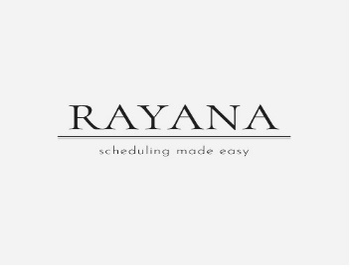 **Price list**

**Universal calendar (2025):**

**Pen calendar: 999.opkr**

The **Universal Company Calendar 2025** is a specific office calendar designed by **Universal,** a well-established brand that offers a wide range of office supplies. Typically, Universal's calendars are known for their practicality, simple design, and functionality, making them a popular choice for businesses and personal use.

**IN VERY AFFORDABLE PRIZES;**

**DISCOUNTED RATE ONLY WEEKLY OFFER**



